**Normalising tone, enhancing movement, balance and control**

*Handle is optional on all exercises* but may be useful for providing support to adult when assisting in certain exercises.*

*\* (Except for grade 3 exercises where handle should be removed)*

[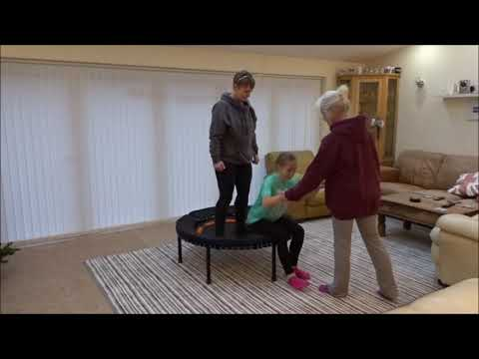](https://www.youtube.com/watch?v=bhuzje6oR5A)

If the link in the video thumbnail above does not play the video on your device, please use this web page to view:   
<https://www.youtube.com/watch?v=bhuzje6oR5A>

Grade 1, Exercise 1: Sits facing adult in stillness

Grade 1, Exercise 2: Differentiates stillness and movement

Grade 1, Exercise 3: Anticipates cause and effect

Grade 1, Exercise 4: Waits patiently for turn

Grade 1, Exercise 5: Maintains eye contact when appropriate

Grade 1, Exercise 6: Compensates for movement when bed is moved in front, behind

and to the side of student (The ‘don’t fall over’ game)

Grade 1, Exercise 7: Regains sitting position when moved off balance

Grade 1, Exercise 8: Enjoys being bounced in sitting position

Grade 1, Exercise 9: Sitting position - initiates movement by pushing into bed with hands

Grade 1, Exercise 10: Sitting position - swimming arm movement to initiate bounce

Grade 1, Exercise 11: Low kneeling position

Grade 1, Exercise 12: Low kneeling position - swimming arms to initiate movement

Grade 1, Exercise 13: High kneeling position

Grade 1, Exercise 14: High kneeling - swimming arms to initiate movement

Grade 1, Exercise 15: Standing in stillness with feet flat on bed

Grade 1, Exercise 16: Standing position - maintains shape while being gently bounced

Grade 1, Exercise 17: Standing position - initiate bounce (bobble)

Grade 1, Exercise 18: Standing position - swimming arms to initiate movement

Grade 1, Exercise 19: Standing position - hang and bounce

Grade 1, Exercise 20: Standing position - pogo in centre

Grade 1, Exercise 21: Standing position - bounce and stop - stillness

Grade 2, Exercise 1: Sitting position with feet on floor - two hand support from one trainer - other trainer pop to stand - stillness

Grade 2, Exercise 2: Sitting position with two trainers (as G2, Ex 1) but with one hand support

Grade 2, Exercise 3: As G2, Ex.1 but student with eyes closed

Grade 2, Exercise 3.1: As G2, Ex.2 but student with eyes closed

Grade 2, Exercise 4: Sitting position - push hands, bounce and half time tweak

Grade 2, Exercise.5: Sitting position - bounce and half time tweak, swimming arms

Grade 2, Exercise 6: Quarter turns in sitting position

Grade 2, Exercise 7: Can achieve two footed jump - landing evenly

Grade 2, Exercise 8: Can achieve two footed jumps repeatedly - landing evenly

Grade 2, Exercise 9: Perform 3 bounces - stop - stillness

Grade 2, Exercise 10: Standing position - bounce with quarter twists

Grade 2, Exercise 11: Standing position - bounce with quarter twists, performs left and right

Grade 2, Exercise 12: Haka (fast knees up and touch)

Grade 2, Exercise 13: Jump to legs astride - stop - stillness

Grade 2, Exercise 14: Jump to legs astride, jump legs together - stop - stillness

Grade 2, Exercise 15: Jump to legs astride - bring arms up, jump to legs together, bring arms down. (Jumping Jack)

Grade 2, Exercise 16: Jumping Jacks continuously)

Grade 2, Exercise 21: Half kneeling - hand support from trainer on floor - other trainer pop to stand to stillness

Grade 2, Exercise 22: As G2, Ex.21 - able to perform right and left knee up

Grade 2, Exercise 24: Half kneeling - swimming arms to stand to stillness

Grade 2, Exercise 25: As G 2, Ex.24 - able to perform right and left knee up

Grade 2, Exercise 26: Back bouncing

**ALL GRADE 3 EXERCISES - HANDLE TO BE REMOVED**

Grade 3, Exercise 1: Jumping with arm movements

Grade 3, Exercise 2: Tuck jump

Grade 3, Exercise 3: Half twist jump

Grade 3, Exercise 4: Straight jump and stop

Grade 3, Exercise 5: Star jump - landing feet together

Grade 3, Exercise 6: Spotty dog - opposite arm and leg

Grade 3, Exercise 7: Spotty dog - same arm and leg

Grade 3, Exercise 8: Routine: Tuck jump, ½ twist, star position